**Design Note: CS6461: Computer Architecture – Simulator (Part I)**

**4th February 2015**

You Zhao G30919114

Yu Ma G40870899

According to professor’s request, we have built up my team – Group 1

Our group members are 1, You Zhao 2, Yu Ma 3 Mengchen Pan 4 Xixi Ai

5 YuFei Zhou

1.Introduction

The Project purpose is to build a structure and operations of a computer system, and use java to design a fairly complex simulation of a computer system.

The Part 1 demands:

Design and implement the basic machine architecture.

Implement a simple memory

Execute Load and Store instructions

Build initial user interface to simulator

2 Our system construction

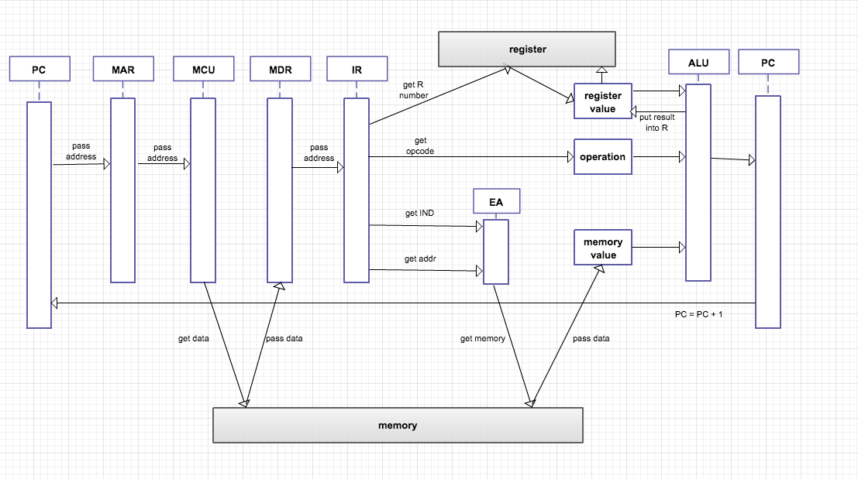

2.1 components part

2.1.1 CPU

a. CPU contains the main logic business of operations to process instructions. By recalling the function defined in registers’ classes, the procedure of computer simulator is completed step by step.

b. CPU is responsible for instantiation of registers’ objects.

c. CPU recall the object of console interface and update the content inside.

2.1.2 Registers

The registers are listed in project description, PC, MAR, MDR and so on. Every register undertakes its own business and connects with each other by transition of data in CPU. So, I am going to define classes for each register if needed.

1. The basic function is data transition which can be simple defined as getter/setter functions for attributes in class.
2. Some register has functions other than getter and setter. If needed, the extra functions is defined in corresponding class.

2.2 Front panel & Framework parts

a. There will be one user interface. It is to display the functions for users for example button power on/off, Single Step and submit input form. And another is console panel that used to show user the status of machine and variables’ value. Also content inside should be synchronized with program.

1. So buttons and text fields are needed and event triggered by user click action is defined in action listener.  Plus, all the user input shall be checked by the program and if any incorrect input detected, the user interface would show user the standard format of input.

2.3 Instruction parts

2.3.1 Functional

1. Main logic business in program is to simulate procedure in computer to execute a series of basic operations. In this project, the operations are AMR SIR SMR AIR. And the logic relationship among registers, they are given by professor during classes of which the programs need to simulate each steps.
2. Extra functions of user interface are detecting user input, user click event
3. The value of variables and status of machine shall be display to user.
4. Memory is loaded from a local file in computer

2.4 Calculation parts

The common program, there should be some tools to handle problems such as encoding as ASCII, check correctness of variables transferred between different modules Functional & non-functional design

3 Test the system by different OP code( sample)

3.1 the operation order

**LDR 2,0,0,10**

1.MAR<-PC

2.MDR<-MEM(MAR)

[3.IR](http://3.ir/" \t "_blank)<-(MDR)

4.opcode<-IR0-5

IX<-IR6-7

R<-IR8-9

IMD<-IR10

ADDR<-IR11-17

5.MAR<-ADDR

6.MDR<-MAR

7.RF(R)<-MDR

8.PC<-PC+1

3.2 demonstration by the real java program

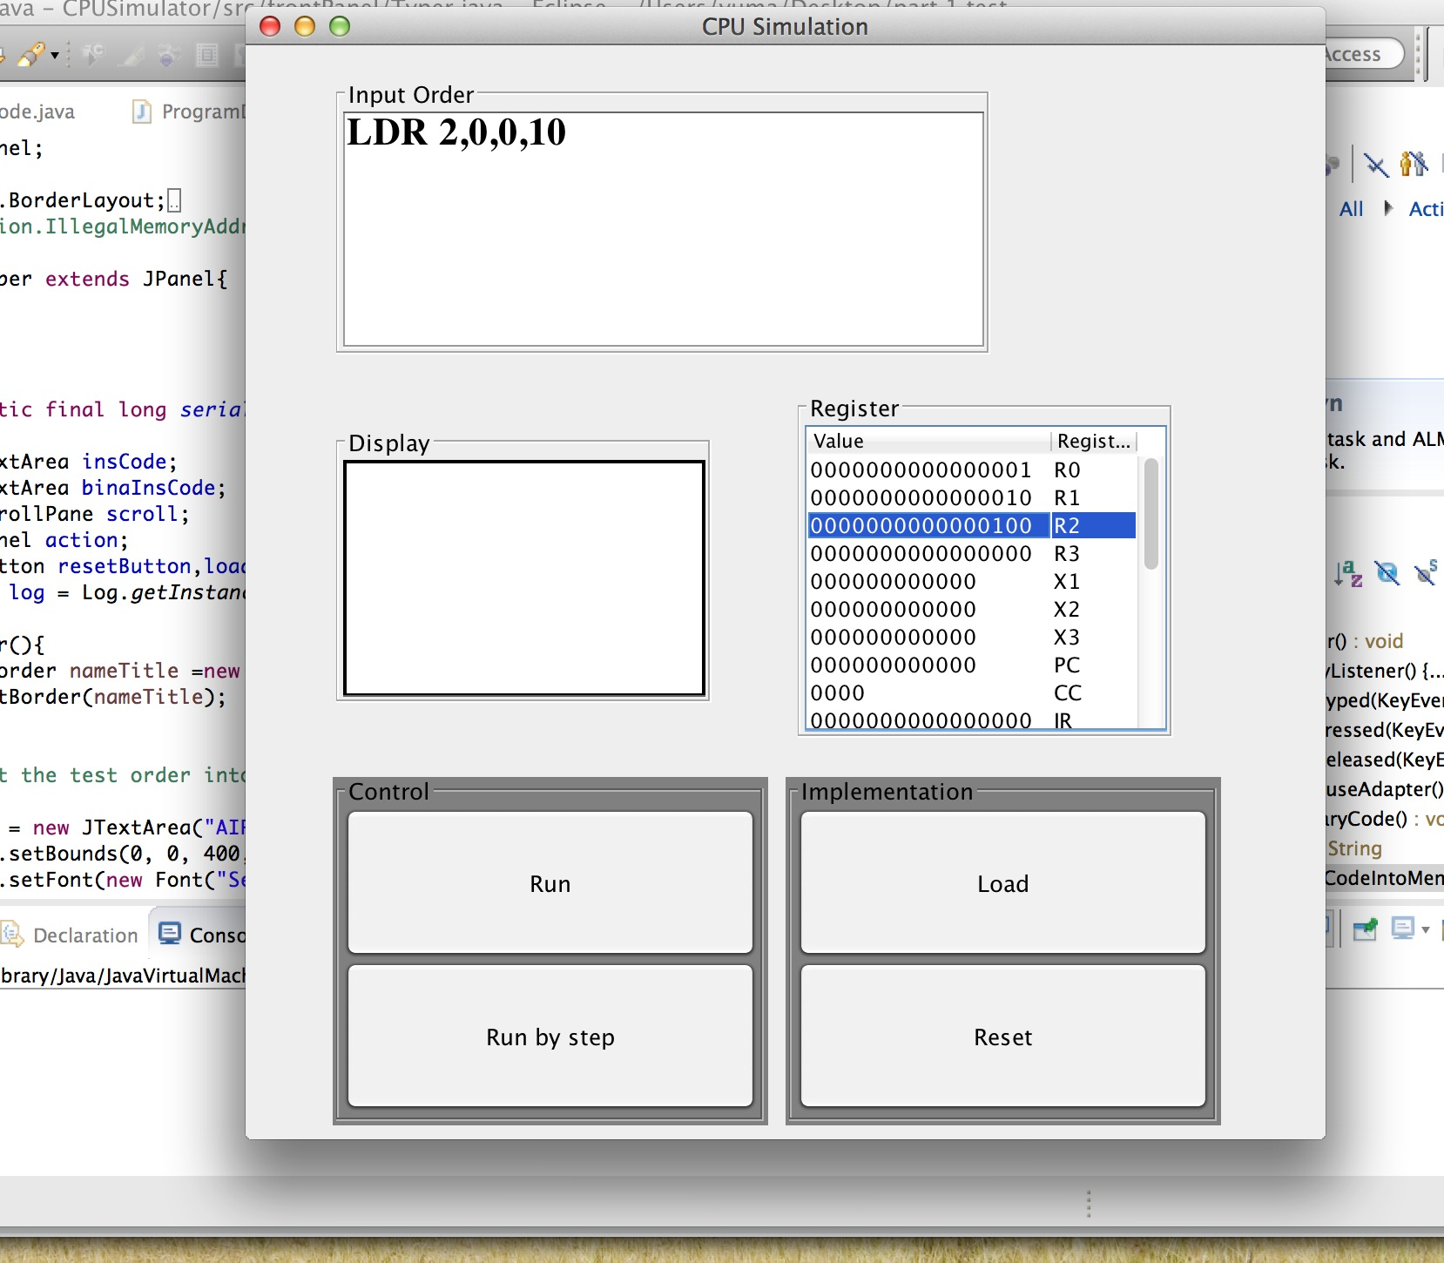

**(1).Start inter face before press Load**

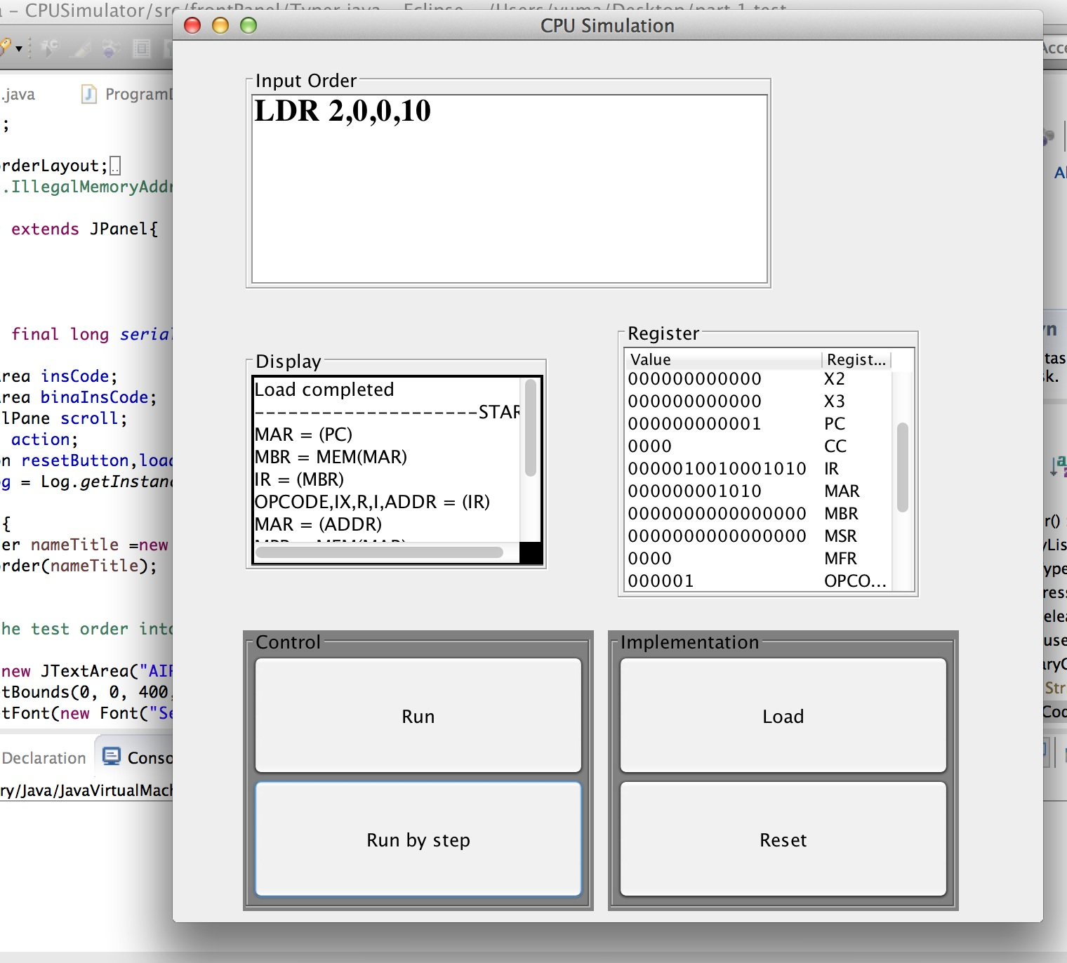

**(2) After operating, Load the type order LDR 2,0,0,10, and the system could work as order The display panel could print the operating order, the register panel could print each instruction address situation**

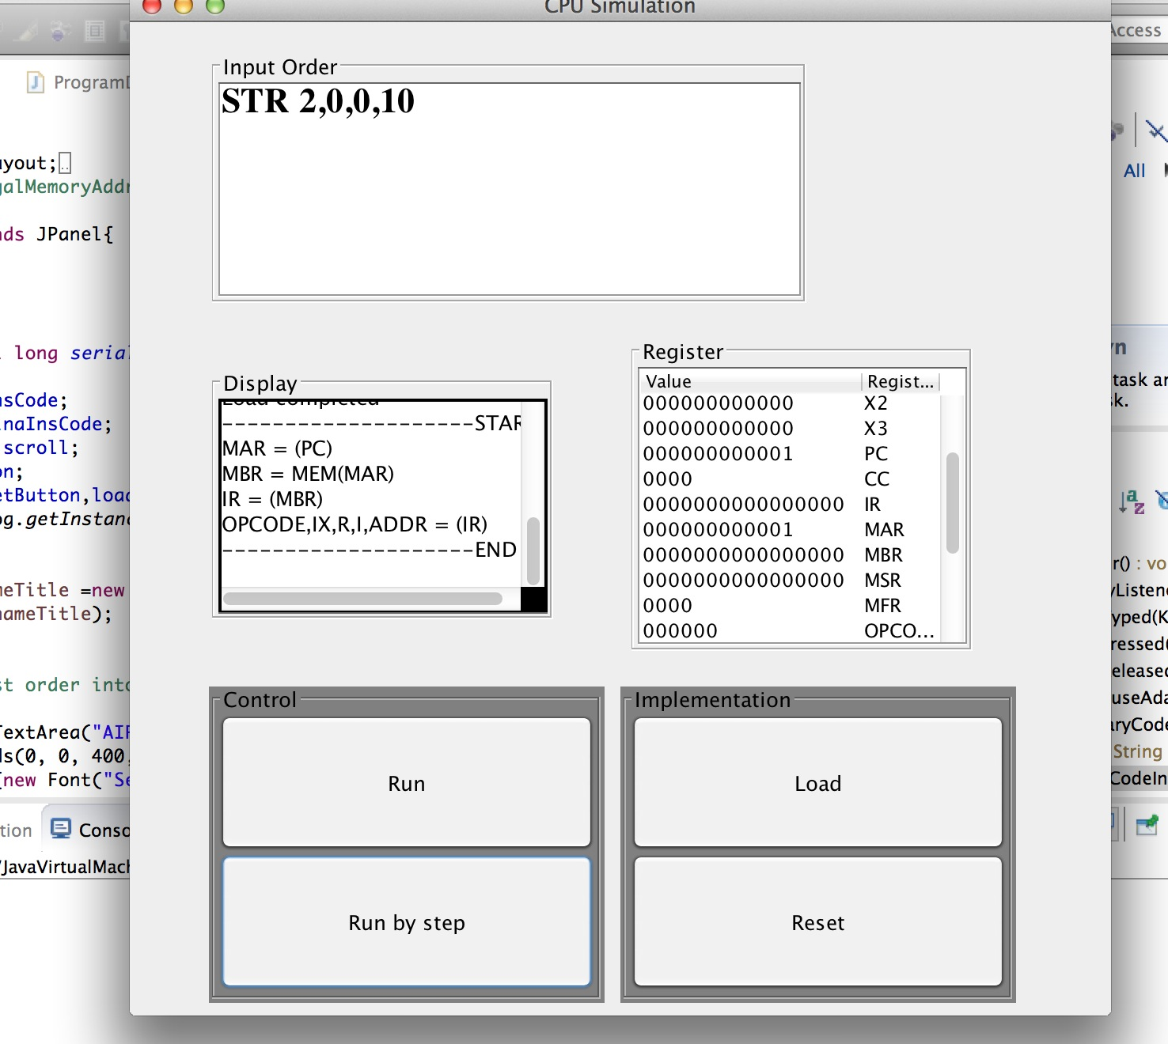

(3) Other operation type, this program also could operate other operation function, as 01 LDR Load Register From Memory, r = 0..3

02 STR Store Register To Memory, r = 0..3

03 LDA Load Register with Address, r = 0..3

04 AMR Add Memory To Register, r = 0..3

05 SMR Subtract Memory From Register, r = 0..3

06 AIR Add Immediate to Register, r = 0..3

07 SIR Subtract Immediate from Register, r = 0..3

4 The main program ideal

The system start by using Java frame, the IDE provide an effective and easy way to build an interface linker with main operation logic program. The basic stone of this program I think is cup class, I use the CPU to be the core of whole program own the same reason with CPU is the core of a computer. I will introduce our program as a travel whatever the destination is operation process. In the beginning, we should know what we will arrive in this processing; so we start from add different instructions. We need store the initial value, so the register we get first, add R0-R3, and then IX, in addition we also seem each operation processes as instructions. This way’s fit the demand of project, a simulator. When the program start running, we want to know what happens in the system, so we use the log, it will output the information what happened in the system.

And then, we will begin execute, but what should execute, java is a object develop environment. In a simple to explain, we seem every single part as class, method. This process looks like to enter different door, each room own different functions. In common situation, it always a common situation happened, but we need to judge it weather a common situation, the invalid value will result Invisible things. After we know it is a common situation, we plan to do what, do not forget, this is a project relate with data store, find, using. If get relationship with data, we need to consider use which way or what kind vector to fill this data. So among whole project, there many kinds vector to store different vector. Array list, block, map, Hash map especially. And use different conditions to build different kinds of links. To realize this assumption, we define several different types, and these types are static values. Because they will not change in the whole programing. As register\_to\_register, register\_to\_memory and so on. Since the computer system is a complex calculation process. For example, if we want to add 3 to 4, how could we get 3, how could we get 4. I make a assumption, 3 is in address [10], 4 is in register R1. Before the getting step, we need to know where could add these two values. In the computer is ALU, similar; we create a instruction called ALU which own same ability with real ALU. Back to the theme, how could find the 3 and put it into register, as it stores in the memory, memory mange these values. One problem is how could we know this value is the value what we want to find. So we assign the index for every value, and this index is called address. It is very vivid as home’s address in the real world. We build Hash map to manage values as address function. It is like [address, value]. And could use very similar calculation method as binary tree algorithm in order to find faster. The value 4 in the register is very like above way to realize.

In the end, we know that among the whole program; there will use some basic math calculation method. Like sub, add, we define these also accord java program ideal, put them in another class called calculation.computering. When we want to use them, we just inherit their name is the position.